**ABSTRACT**

Since time immemorial ‘security’ has been one of the prime concerns of human beings. Beside food, shelter, healthcare and procreation what has been of utmost importance to us is our security measures. This is why fire and weapons came into being long back during the initial course of evolution of human being. In fact in today’s world each and every country spends a major chunk of their total budget on defence and security measures.

But in due course of time life has changed and has changed over the entire globe due to globalization, privatization, industrialization and all such ongoing activities. World is a global village now and with such a diverse and complex ambience the need to protect ourselves , our strategic databases, shops, offices , factories, schools, colleges, in fact all our productive and non-productive centers has grown manifold.

That is why there is a need of a smart security system, which should be easily employable, should be cost effective, robust and reliable. Therefore we have come up with a smart solution, i.e. a smart security system, where there is a limited numbers of assigned users, who can access the security system with the set of smart cards and passwords. Password changing facility is available to both users as well as to administrator. Besides there is a scope of resetting the whole set up. To make it robust reliable and tamperproof, there is a scope that three successive wrong password entries would lock the security system up. This can further be resolved by administrator only. Plus there is a scope of displaying different important messages during operations to make it user friendly. Like a message “insert your card properly” appears on screen, when card is not inserted properly. We hope that our effort will bring about a more secured life, lifestyle and world.

**SECURITY SYSTEM CIRCUIT MODEL :-**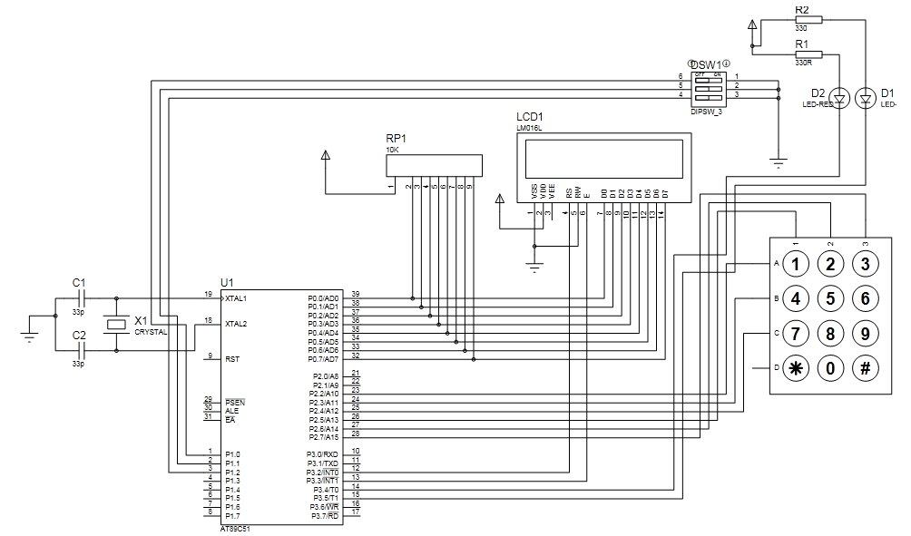

**HARDWARE USED :-**

1. 7805 (Voltage Regulator )

2. at89c51(8051 Microcontroller)

3. 16x2 Characters LCD

4. 10K Pull Up Resistor Pack (SIP)

5. Crystal Oscillator (11.0592 MHz)

6. 33 pf Ceramic Capacitor

7. LEDs (Green & Red)

8. Micro Switches (For 3x3 Matrix Keyboard)

9. MOC7811 (Ocptocoupler for Card Reader)

10. Male & Female Connectors

11. 9 V Battery

12. Power Jack

13. 10K Preset

14. 10 uf Electrolytic Capacitor

15. 330 ohm Resistors

16. 4.7K Resistors

17.10 K Resistors

**How it works : -**

* This project is valid for 2 users….
* As project starts it display’s initial user friendly messages…. After that A message will display as “INSERT CARD”…
* Now when we insert the card and it will detect the corresponding user….either User1 or User2…
* It will also displays a message “INVALID CARD” if corresponding card is not true…
* When device detects correct user, it will ask for the password by displaying a message “Enter Password”..
* If the user enters the wrong password, a message displays as “wrong password” and it will again ask for password till it will get continuous 3 wrong password.. and buzzer will sound on every wrong password.
* If password is correct then message displays as ‘’Correct password” and the door opens, it is shown by rotation of stepper motor. Motor will rotate in backward direction shows that door is shutting down after some time…
* Now the device will continuously check for the other users…